Categories and games based on the Cattell-Horn-Carrol theory of Cognitive Abilities.

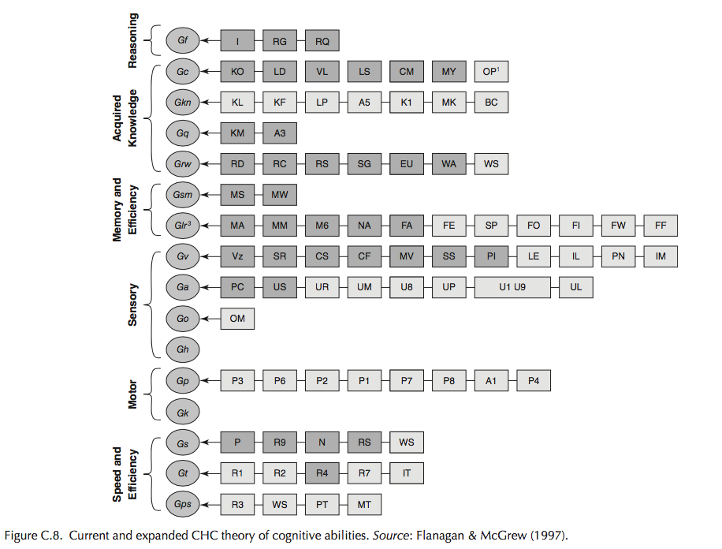

For more information, please consult the “CHC Theory.pdf” document, where both the Cattell-Horn-Theory and its categories are explained with considerable detail.

**Fluid Intelligence (*Gf*)**

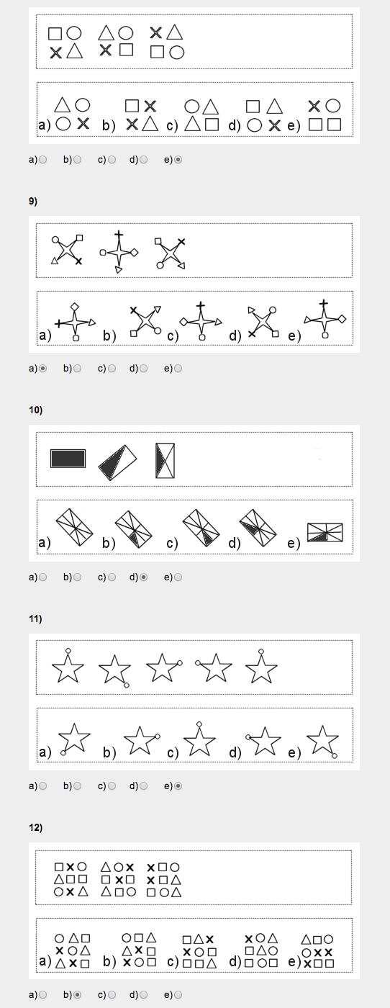

(Use auto generated patterns so tests never repeat. Hard, but beats making 200 different tests)

**Crystallized Intelligence (*Gc*)**

Language skills. A lot of different things possible here. Words to meanings, grammatical games,

**General (Domain-Specific) Knowledge (*Gkn*)**

Hard to do with few people. Later one can create categories and questions regarding things inside those categories, comparing only scores inside each category.

**Quantitative Knowledge (*Gq*)**

Mathematical games. A whole lot of them exist already.

**Reading/Writing Ability (*Grw*)**

Having words flash continuously faster telling of a certain subject. In the end, ask a question regarding what was read.

Writing speed: How fast one can copy a given sentence.

**Short-Term Memory (*Gsm*)**

Memory Span (MS) :Recall temporally ordered elements in the correct order after a single presentation.

Working Memory (MW) : Store and perform a set of cognitive operations on information that requires divided attention and the management of the limited capacity of short-term memory. How? Not sure. Maybe make the user play a number of different games at the same time, all requiring the user to remember something about the current state of the game. The bigger the number of games a user can play simultaneously, the higher the score.

**Long-Term Storage and Retrieval (*Glr*)**

Free-Recall Memory (M6) : Recall as many unrelated items as possible, in any order, after a large collection of items is presented.

Word Fluency (FW) : Rapidly produce words that have specific phonemic, structural, or orthographic characteristics (independent of word meanings). Example: Write the largest number of words starting with P.

**Visual Processing (*Gv*)**

Speeded Rotation (Spatial Relations; SR) : Show an image and have the user choose which one is that image rotated from a series of images.

Flexibility of Closure (CF) :Find a shape or an image inside a bigger and complex image or pattern.

**Auditory Processing (*Ga*)**

I’ll leave this one to the musician…

**Olfactory Abilities (*Go*)**

Doesn’t apply.

**Tactile Abilities (*Gh*)**

Doesn’t apply.

**Psychomotor Abilities (*Gp*)**

Hit the target games. Moving targets, testing not the reflex but the overall coordination of mind-fingers.

A number of targets that slowly turn gradually red, needing to be hit exactly when they are red. Maybe changing in size as well.

Example: aimbooster.com

**Kinesthetic Abilities (*Gk*)**

Doesn’t apply. (Maybe with movement sensors? A bit too difficult for now)

**Processing Speed (*Gs*)**

Being asked to read a passage (on a self-paced scrolling video screen) as quickly as possible and, in the process, touch the word *the* with a stylus pen each time it appears on the screen, is an example of *Gs*. The individual’s *Gs* score would reflect the number of correct responses (taking into account errors of omission and commission).

**Decision Speed/Reaction Time (*Gt*)**

*Gt* may be measured by requiring a person to read the same text at his or her normal rate of reading and press the space bar as quickly as possible whenever a light is flashed on the screen. In this latter paradigm, the individual’s score is based on the average response latency or the time interval between the onset of the stimulus and the individual’s response

**Psychomotor Speed (*Gps*)**

Movement time: How fast one can connect two dots. Two black dots appear that have to be connected while two grey dots remain on the background, that will turn black as soon as the previous dots are connected. So on ad infinitum.